Preschool Teacher Survey Results 2024

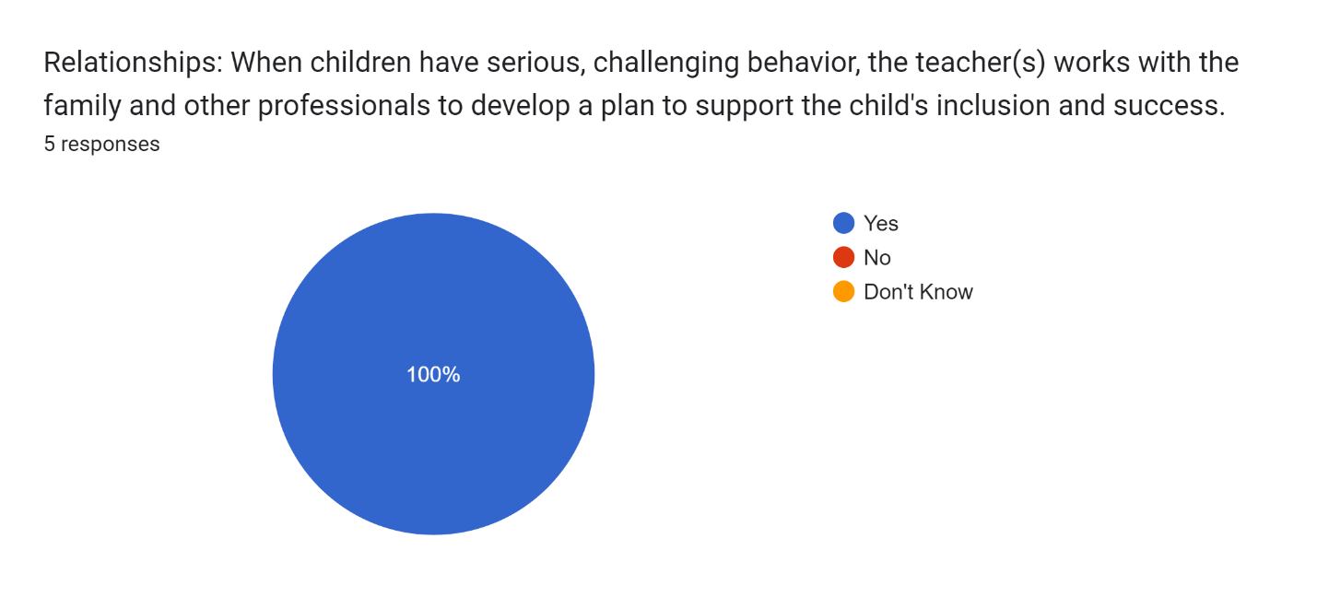

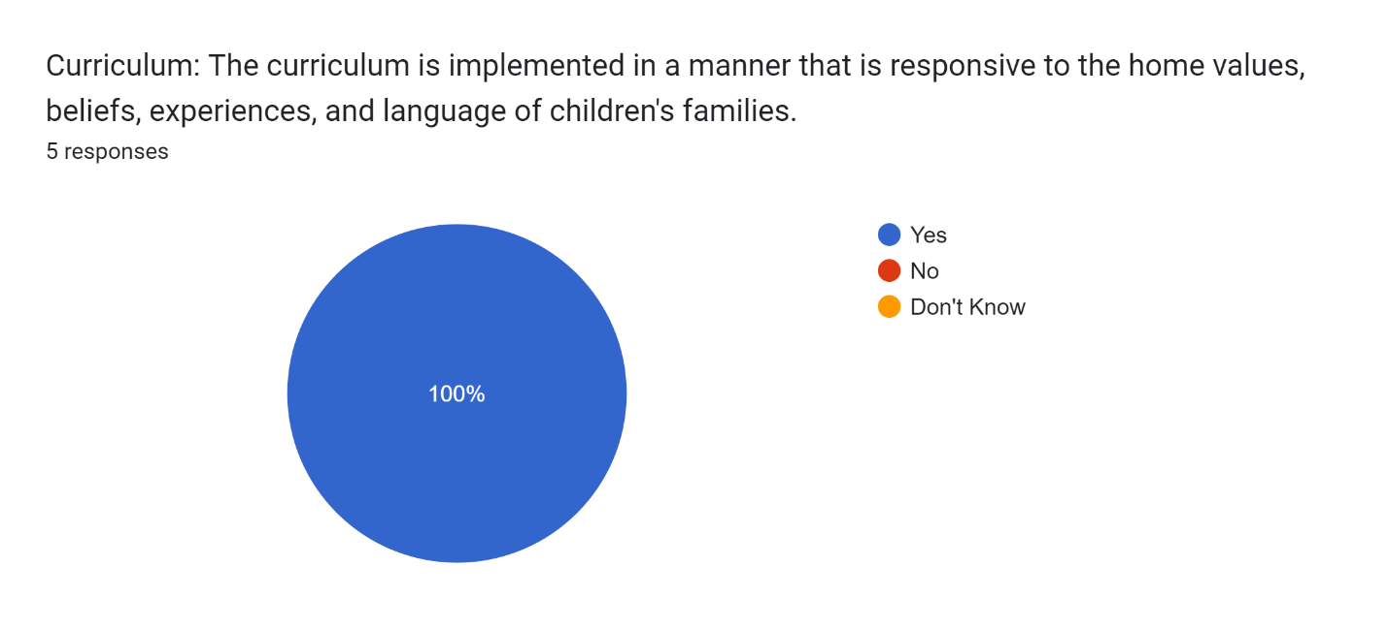

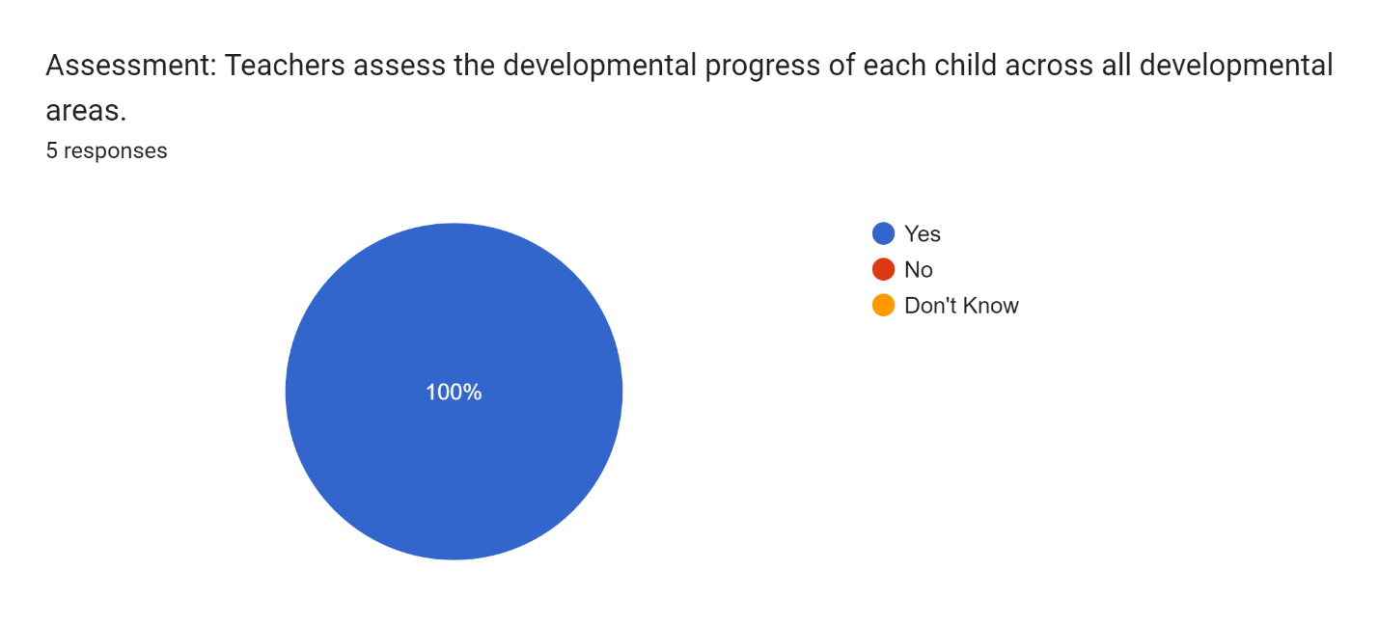

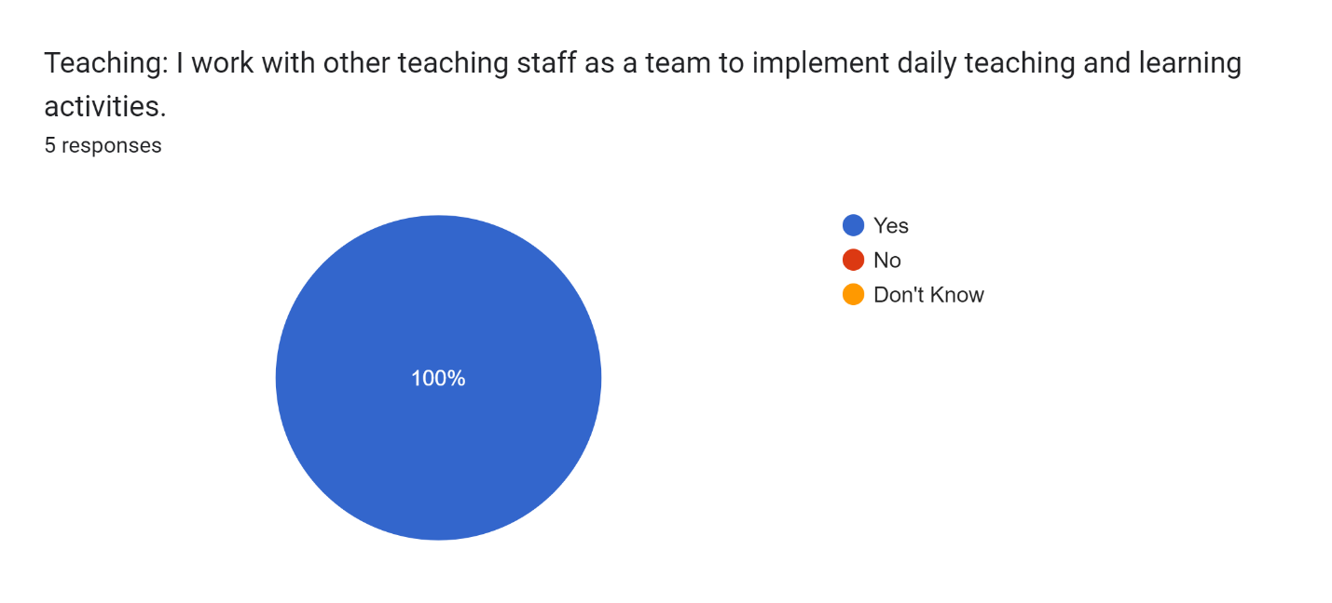



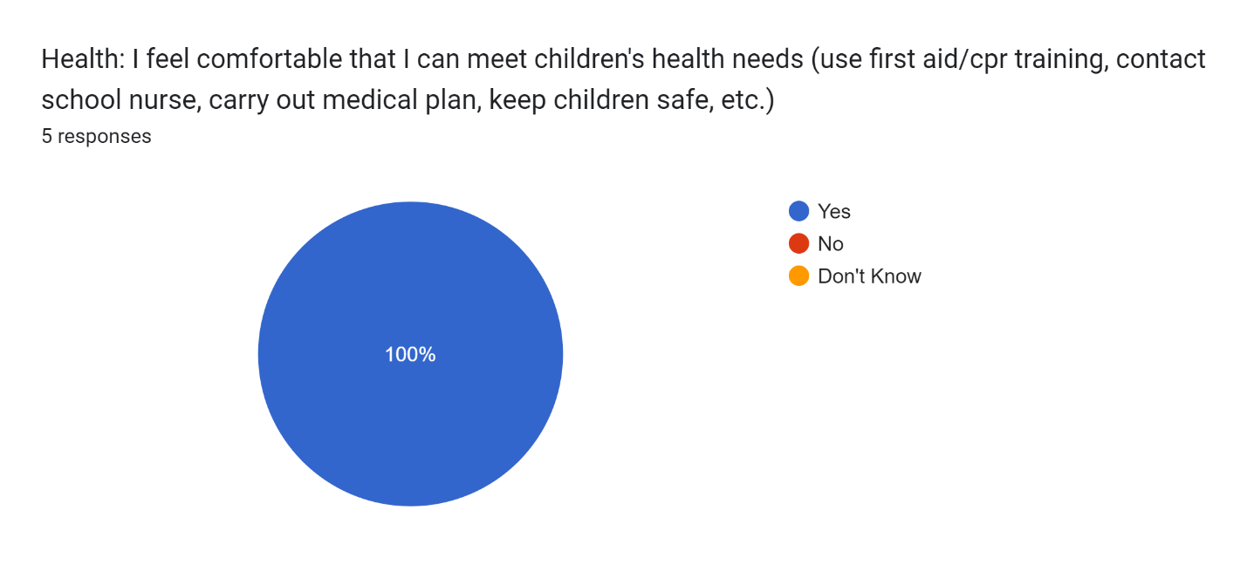

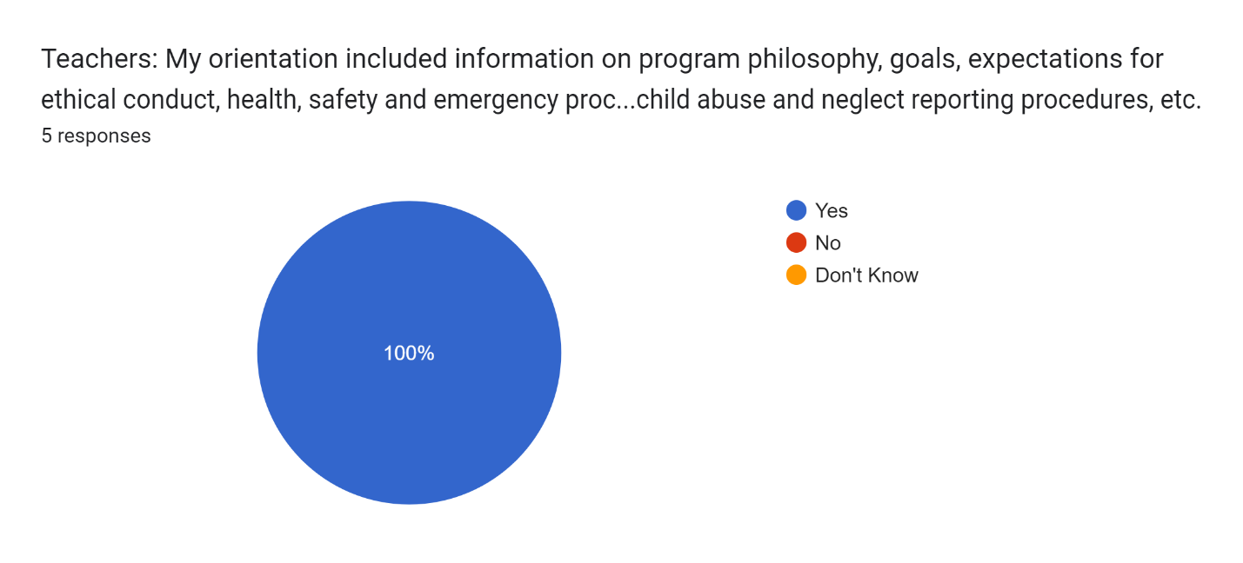

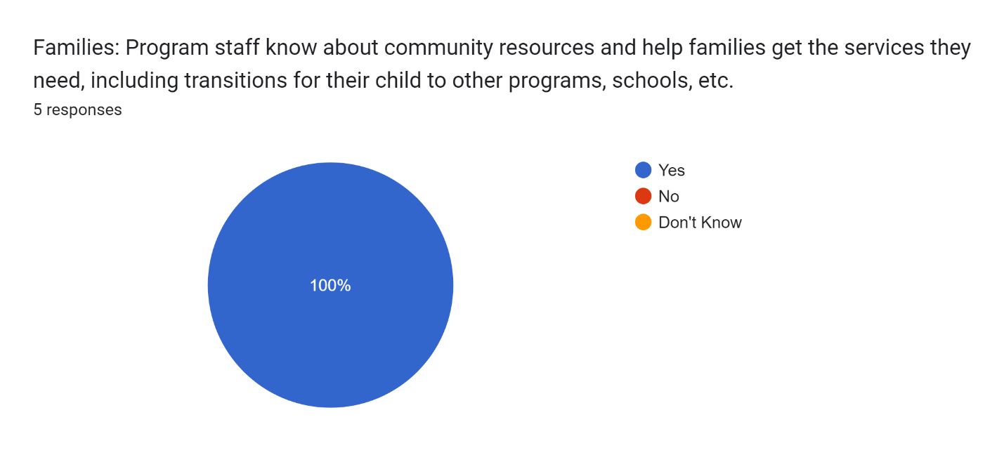

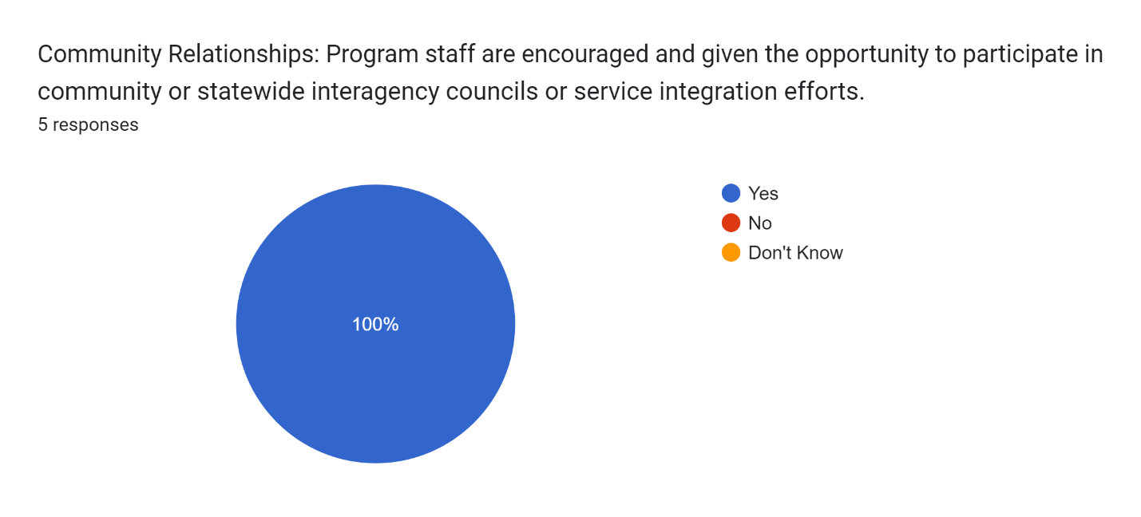

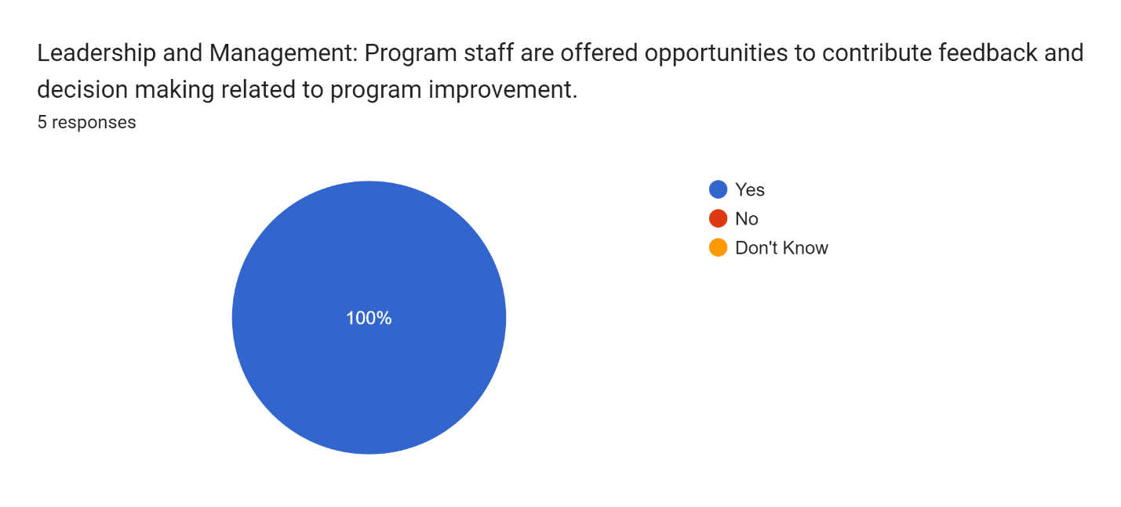

Forms response chart. Question title: General: I feel respected by the program staff and that my contributions are valued.
. Number of responses: 5 responses.

Reflection: Consider and share areas of strength, and of challenge, for the program and for you individually.5 responses

I feel like we all work well together. We can just fill in where there is a need without being asked. This can also be a challenge when other staff is in the room covering. I know I can tend to just do what needs to be done instead of asking for new staff member to help.

The program does a nice job of being responsive to family requests/needs, and building a foundational relationship. An area of challenge is opportunities for collaboration among program staff - consult on routines/activities/expectations, for the group and individuals.

Personally, balancing the needs of the students, families, and staff, as well as program-wide, can be challenging at times.

It's amazing being able to work beside such amazing teachers that pour their heart and souls into each child to ensure their success in and out of the classroom. Whenever I have something to share I always feel listened to and respected. It truly is an honor to me to be able to say I'm part of such a great program as well as the success of all students.

I believe we all work well together. A strength is, the end of each day I reflect about how the day went and how I can improve myself to better the program and the children’s experience. A challenge is accepting and/or delegating when other staff come into the classroom to help.