Preschool Family Survey 2024

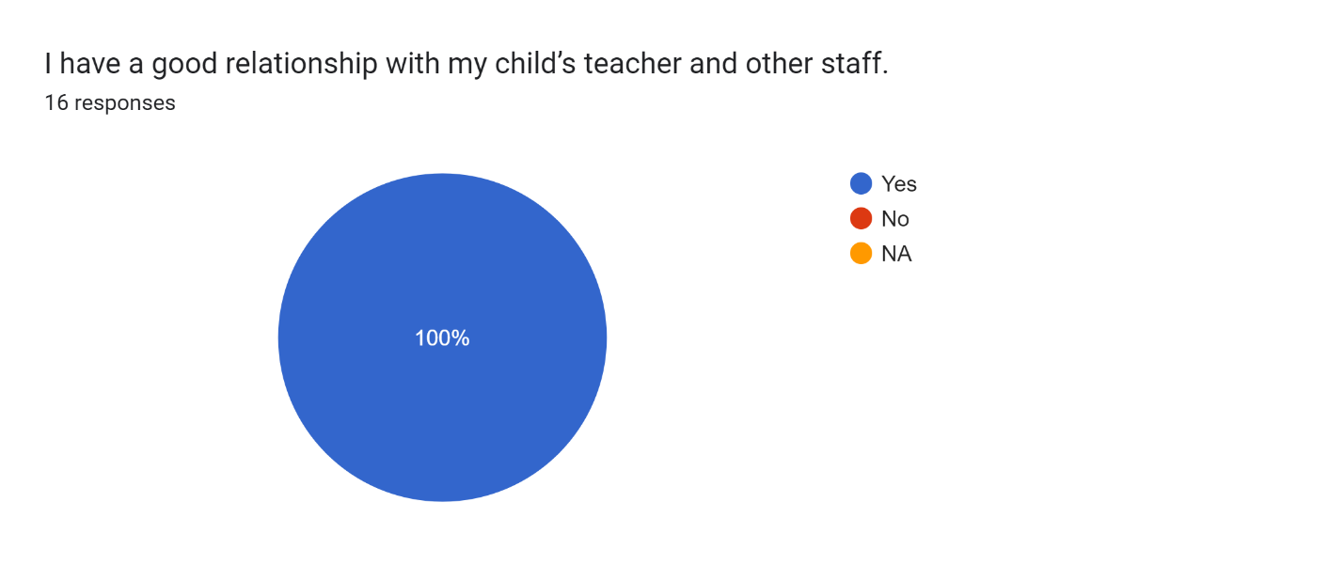

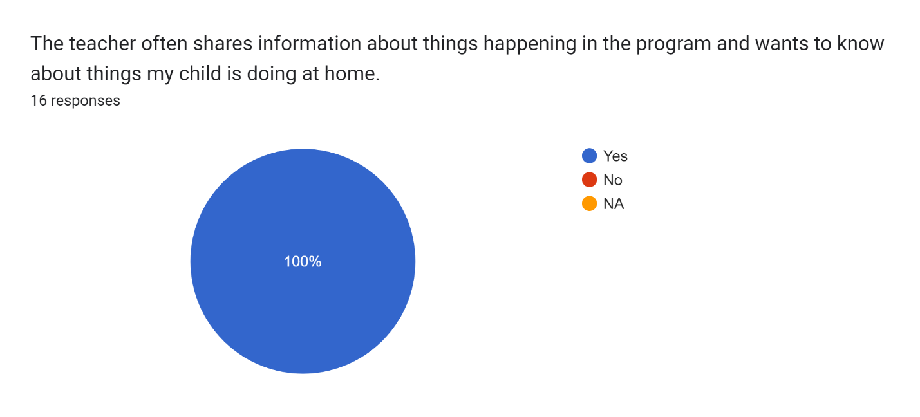

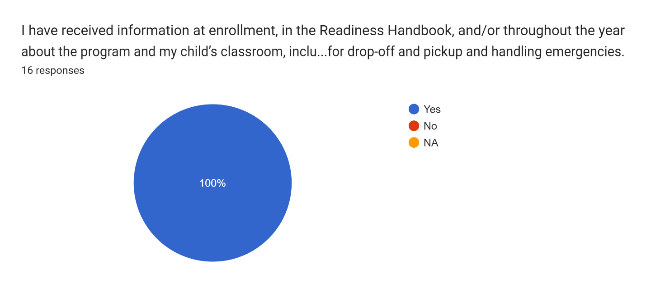

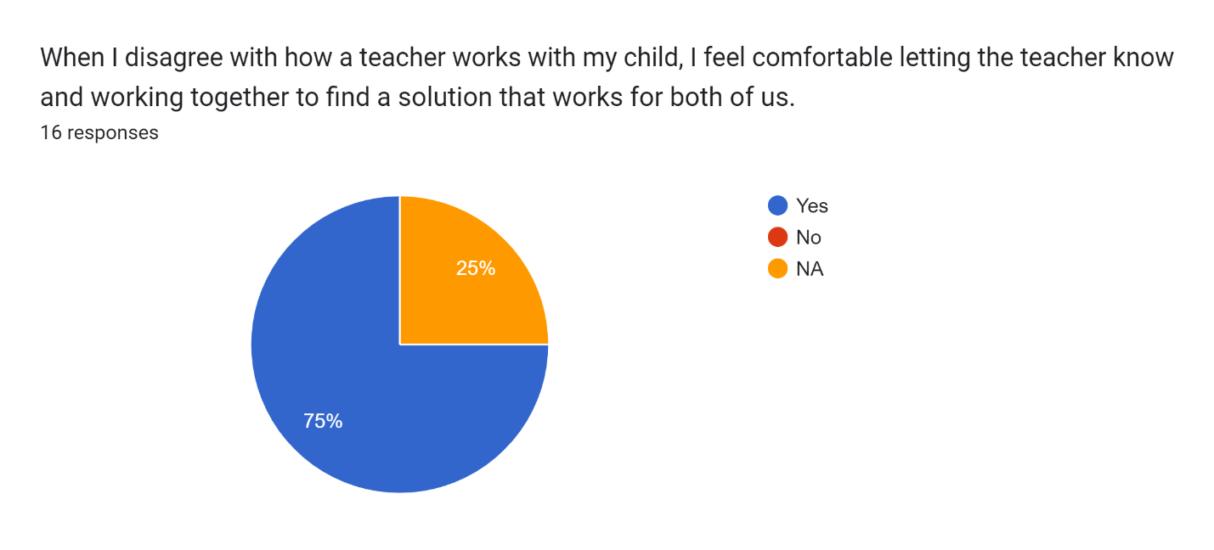

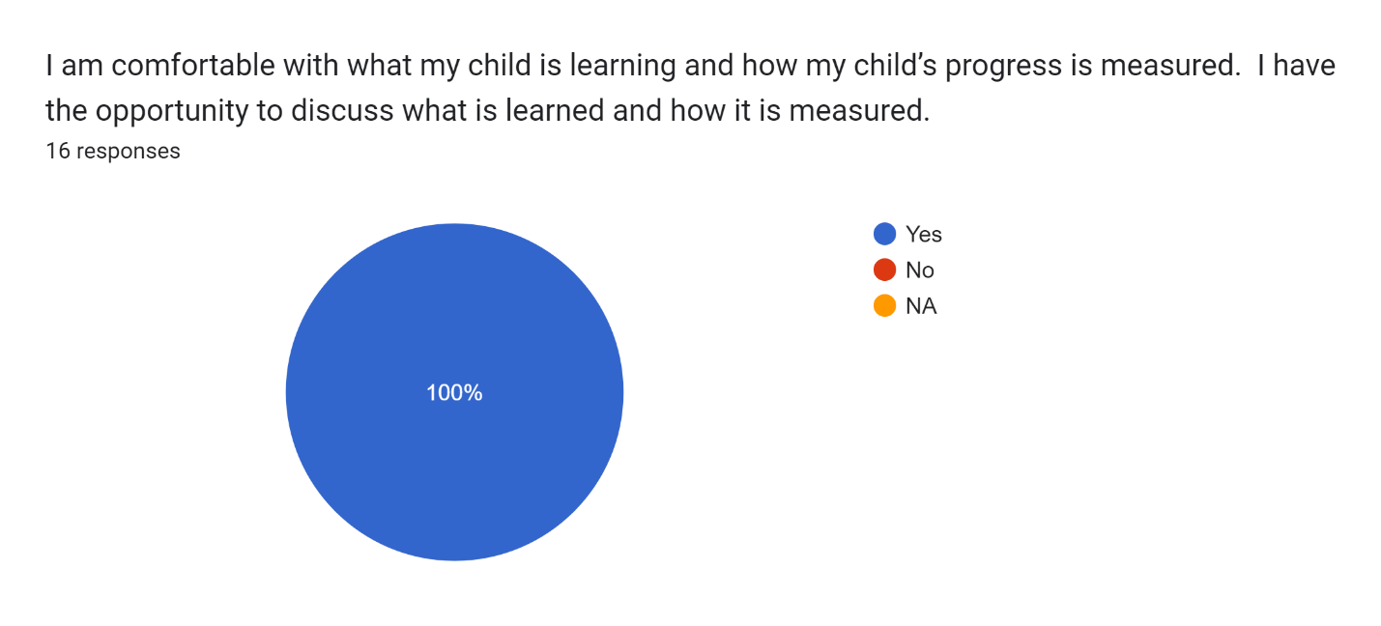

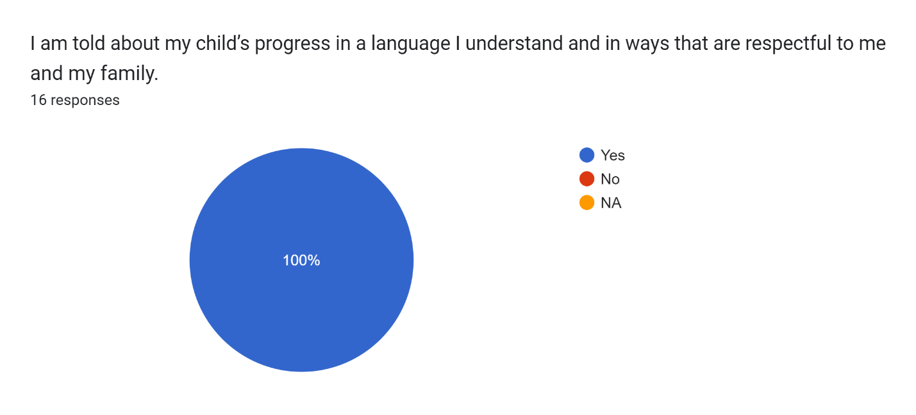

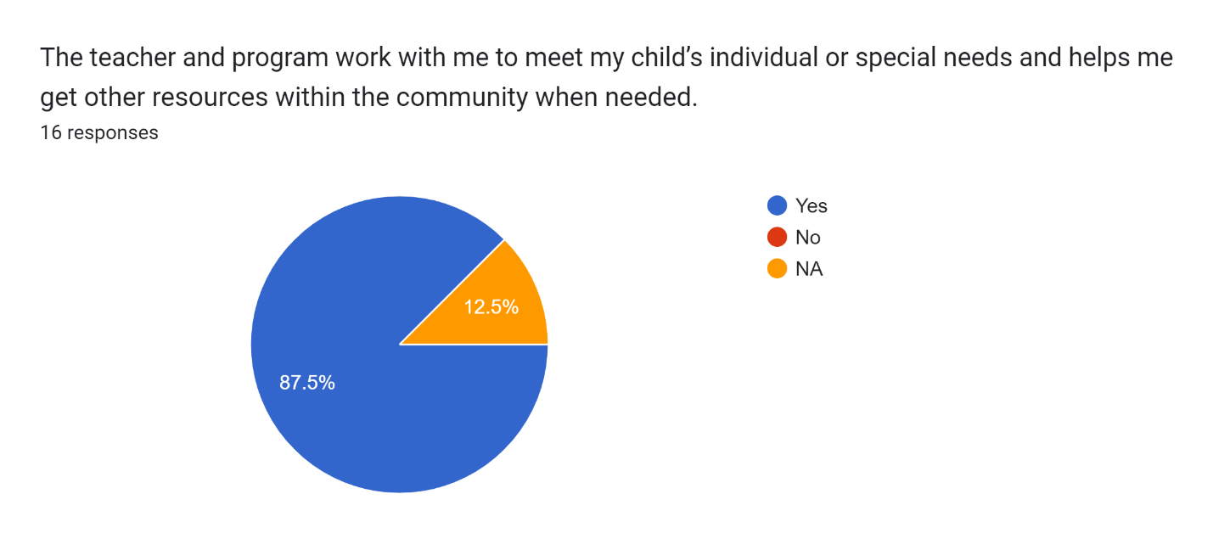

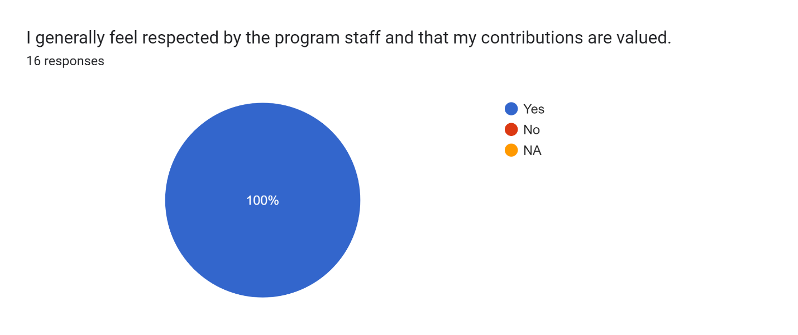

Please list any questions or comments you may have for me.16 responses

None

N/a

No concerns. Thank you for teaching my little man.

Can you move to Kindergarten with Gabriella lol. In all seriousness the last four years my girls have been in your classroom have been great. Your classroom sets the bar very high for the years to come and I cannot say enough how much I appreciate all that you do.

Very happy with the Readiness program, Laurel absolutely loves school, I feel she learns alot!

I have none

No questions happy with the teachers and aids and feel my child is well taken care of !

NONE

You are a wonderful teacher and we are so happy that Tony has been able to work with you!

N/A

Na

.

I have no questions at this time

My child feels socially and emotionally regulated and loves to learn